CS 255 System Design Document Project Two
Mark Geisler
Mark.geisler@snhu.edu
2/17/2026

UML Diagrams

UML Use Case Diagram
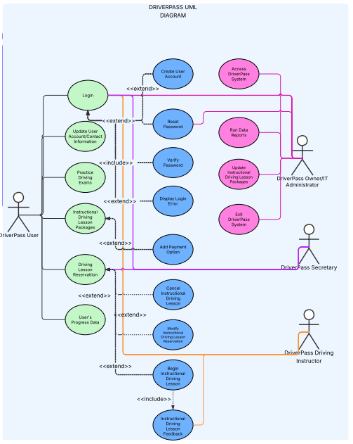

UML Activity Diagrams
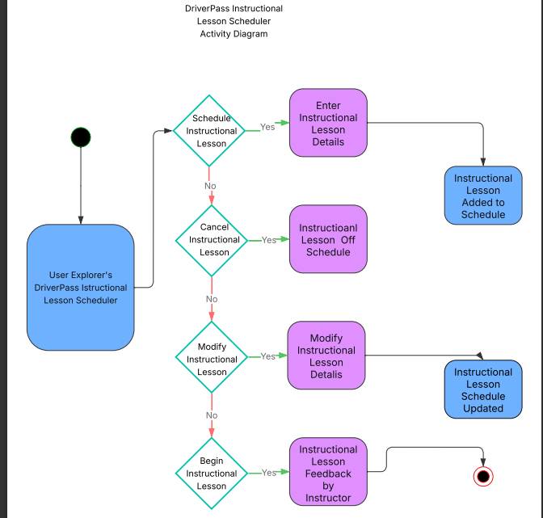

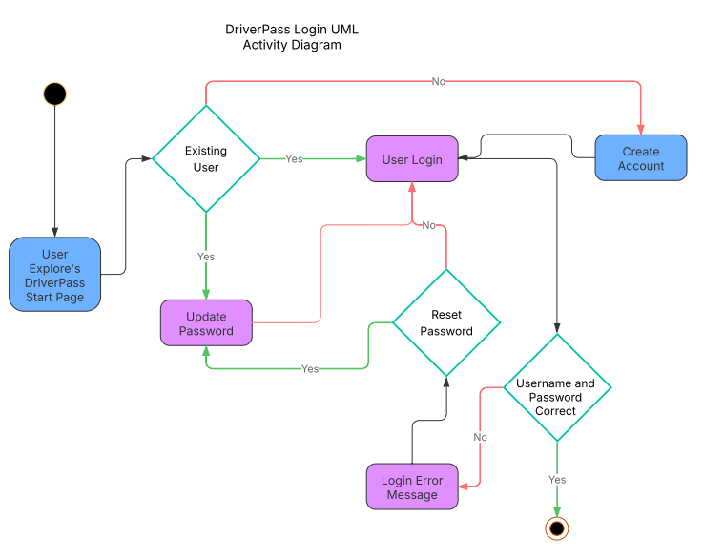

UML Sequence Diagram
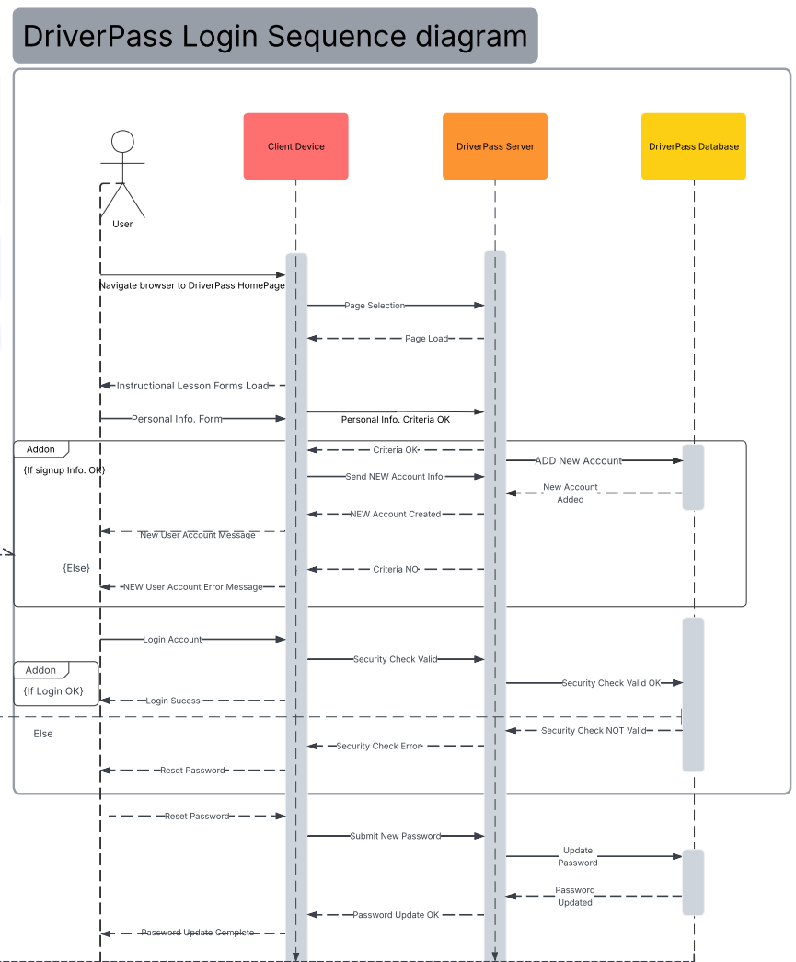

UML Class Diagram
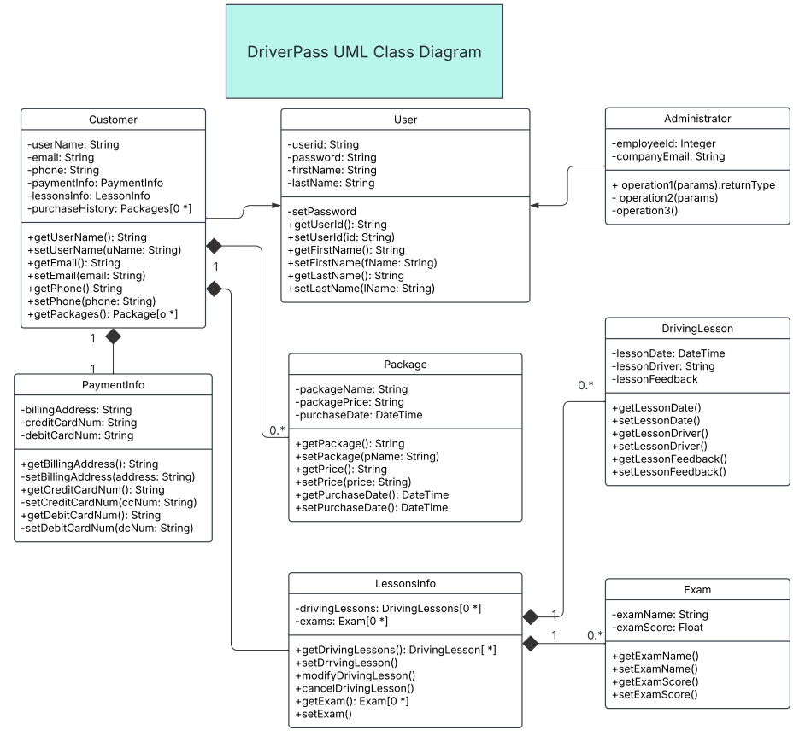

Technical Requirements

Technical Required Hardware:
- User devices browser capable
- Smart Phones
- Tablets
- Laptops
- Desktops
- Cloud servers
- Linux

Technical Required Software:
- Supported Browsers
- Edge
- Chrome
- Firefox
- Safari
- Up to date Security Suites
- Multiplatform Capabilities
- Windows
- Mac
- Linux
- Web based Distribution Operating System Linux

Technical Required Tools:
- Internet
- WIFI
- 4G/5G/6G
- Ethernet
- Continuous Development, Integration of software including Front and Backends
- Lucid Chart Diagram Planning
- UML Use Case Diagram
- UML Activity Diagrams per Use Case
- UML Sequence Diagrams per Activity
- UML Case Diagram in total

